Write the correct activity under the pictures.
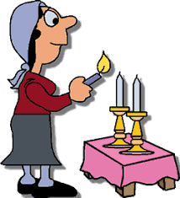 | 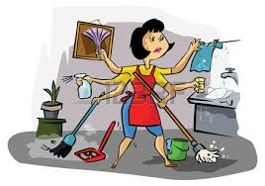 | 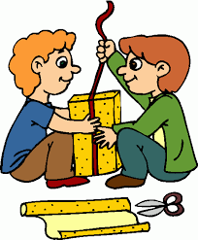 | 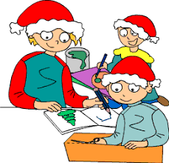
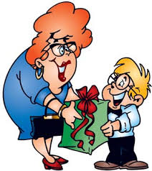 | 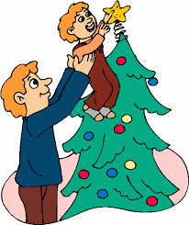 | 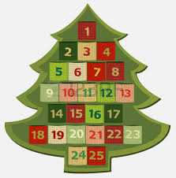 | 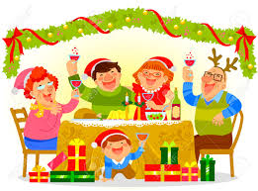
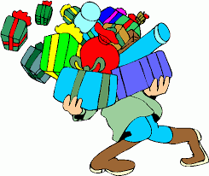 | 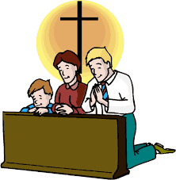 | 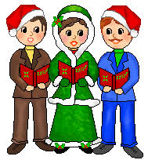 | 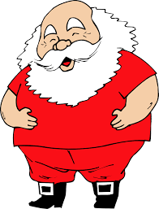
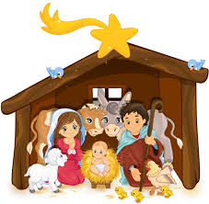 | 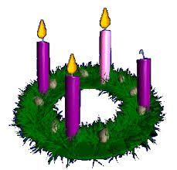 | 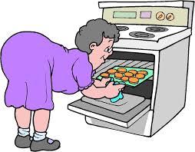 | 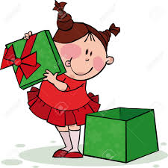
wrap presents – decorate the Christmas tree – dress up as Santa Claus - go shopping – draw a picture – bake cookies – clean the house – sing carols – light a candle – hang an Advent calendar on the wall – put up a crib – bring a present – open a present – have dinner – go to church – open the present – have dinner – go to church – celebrate Advent

light a candle | clean the house | wrap presents | draw a picture
bring a present | decorate the Christmas tree | hang an Advent calendar on the wall | have dinner
go shopping | go to church | sing carols | dress up as Santa Claus
put up a crib | celebrate Advent | bake cookies | open the present

